**21**

**Heat Engines, Entropy, and the**

**Second Law of Thermodynamics**

|  |
| --- |
| **CHAPTER OUTLINE** |

21.1 Heat Engines and the Second Law of Thermodynamics

21.2 Heat Pumps and Refrigerators

21.3 Reversible and Irreversible Processes

21.4 The Carnot Engine

21.5 Gasoline and Diesel Engines

21.6 Entropy

21.7 Entropy in Thermodynamic Systems

21.8 Entropy and the Second Law

* An asterisk indicates a question or problem new to this edition.

|  |
| --- |
| **SOLUTIONS TO THINK-PAIR-SHARE AND ACTIVITIES** |

**\*TP21.1** **Conceptualize** Review Section 21.4 and Figures 21.9 and 21.10 to make sure you understand the Carnot cycle.

**Categorize** We categorize the engine as operating in a Carnot cycle, allowing us to further categorize the processes in the cycle as adiabatic and isothermal.

**Analyze** (a) Let us begin by entering into the table the information provided in the problem statement:

|  |  |  |  |
| --- | --- | --- | --- |
| **Point in Cycle** | ***P* (kPa)** | ***V* (L)** | ***T* (K)** |
| *A* | 1 400 | 10.0 | 720 |
| *B* |  |  |  |
| *C* |  | 24.0 |  |
| *D* |  | 15.0 |  |

Because process *A* → *B* is isothermal, we know that *TB* = 720 K. Let us now work our way around the cycle. We begin from point *D* so that we can take advantage of Equations 20.37 and 20.39 for adiabatic processes. For the adiabatic process *D* → *A*, we can write



Because process *C* → *D* is isothermal, we know that *TC* = 549 K. Now use the ideal gas law (Equation 18.9) to find the pressure at *C*:



Now use Equations 20.39 and 20.37 again for the adiabatic process *B* → *C*:



Entering these numbers in the table, we have:

|  |  |  |  |
| --- | --- | --- | --- |
| **Point in Cycle** | ***P* (kPa)** | ***V* (L)** | ***T* (K)** |
| *A* | 1 400 | 10.0 | 720 |
| *B* | 875 | 16.0 | 720 |
| *C* | 445 | 24.0 | 549 |
| *D* | 712 | 15.0 | 549 |

(b) We begin by entering zero for the change in internal energy for the isothermal processes and for the heat in the adiabatic processes:

|  |  |  |  |
| --- | --- | --- | --- |
| **Process in Cycle** | ***Q* (kJ)** | ***W* (kJ)** | ***E*int (kJ)** |
| *A* → *B* (isothermal) |  |  | 0 |
| *B* → *C* (adiabatic) | 0 |  |  |
| *C* → *D*  (isothermal) |  |  | 0 |
| *D* → *A*  (adiabatic) | 0 |  |  |

Use Equation 21.12 to find the work done in the isothermal processes:





Now, from the first law of thermodynamics, for an isothermal process,

 (isothermal)

Therefore,



For the adiabatic processes, we can use Equation 20.26 to find the change in internal energy:





Now, from the first law of thermodynamics, for an adiabatic process,

 (adiabatic)

Therefore,



Entering these numbers in the table, we have the following:

|  |  |  |  |
| --- | --- | --- | --- |
| **Process in Cycle** | ***Q* (kJ)** | ***W* (kJ)** | ***E*int (kJ)** |
| *A* → *B* | 6.58 | –6.58 | 0 |
| *B* → *C* | 0 | –4.99 | –4.99 |
| *C* → *D* | –5.02 | 5.02 | 0 |
| *D* → *A* | 0 | 4.99 | 4.99 |

(c) From the table in part (b), we find, using Equation 21.2,



(d) From the table in part (a), we find, using Equation 21.8,



**Finalize** Notice that we obtained the same efficiency in parts (c) and (d). That must be true, since both tables refer to the same engine, which happens to be a Carnot engine.

*Answers:* (a)

|  |  |  |  |
| --- | --- | --- | --- |
| **Point in Cycle** | ***P* (kPa)** | ***V* (L)** | ***T* (K)** |
| *A* | 1 400 | 10.0 | 720 |
| *B* | 875 | 16.0 | 720 |
| *C* | 445 | 24.0 | 549 |
| *D* | 712 | 15.0 | 549 |

(b)

|  |  |  |  |
| --- | --- | --- | --- |
| **Process in Cycle** | ***Q* (kJ)** | ***W* (kJ)** | ***E*int (kJ)** |
| *A* → *B* | 6.58 | –6.58 | 0 |
| *B* → *C* | 0 | –4.99 | –4.99 |
| *C* → *D* | –5.02 | 5.02 | 0 |
| *D* → *A* | 0 | 4.99 | 4.99 |

(c) 23.7% (d) 23.7%

**\*TP21.2** **Conceptualize** For each die, the probability of a certain number to be face-up is 1/6.

**Categorize** We need to use simple statistics to answer the questions in the problem, using the equal-probability situation noted in the Conceptualize step.

**Analyze** (a) For three dice, there are 16 possible macrostates, ranging from 3 (three 1s) to 18 (three 6s). The probability of a certain macrostate is related to the number of microstates. For example, for a macrostate of 5, there are six possible microstates: 1–1–3, 1–2–2, 1–3–1, 2–1–2, 2–2–1, and 3–1–1.

Following this process for all possible macrostates generates the probability graph for three dice as follows:

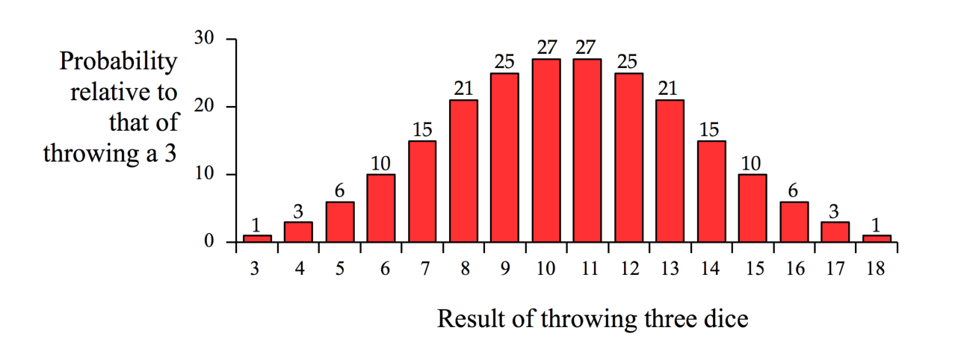

The histogram should have a similar shape.

(b) The things to notice from the histogram or the probability graph as the number of dice increases are the following:

• The graph continues to be symmetric about the midpoint.

• The probability of the middle value rises sharply as we add dice: by only adding one die (from two dice to three dice), the probability of the middle value rises from six times that of the lowest value to 27 times that of the lowest value. (It rises to 146 times the lowest probability for four dice.)

• Think about an envelope curve—that is, a curve that is drawn through the tops of all the bars. An envelope curve for *one* die is a flat, horizontal straight line: the probability is the same for all possible results 1 through 6! The envelope curve is two straight lines for two dice, but is a curved line for three dice:

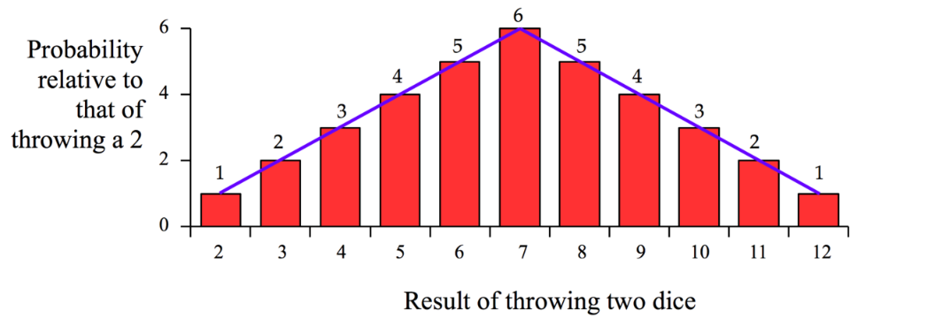

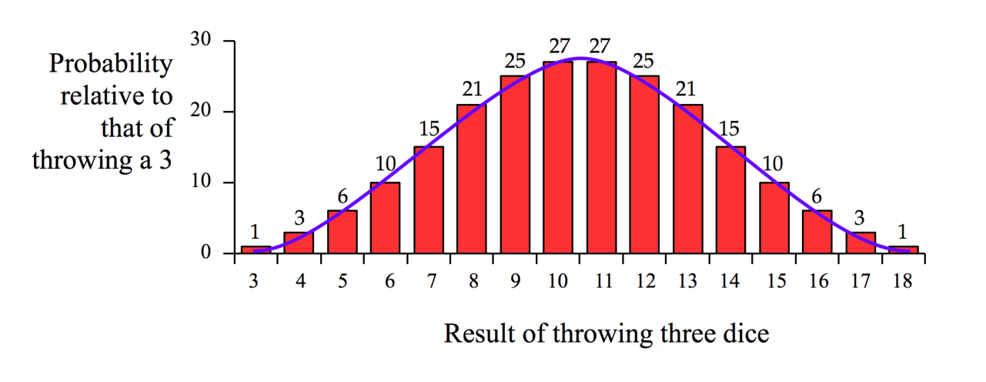

Notice that the result at which the probability maximizes is 7 for two dice and 10.5 for three dice. (The results 10 and 11 have the same probability.) Because the curves are symmetric, we can argue that, for *n* dice, the range of values for the result is from *n* to 6*n*, and the result *R*max where the probability maximizes is the average of these values:



For *n* = 2, this gives *R*max = 7; for *n* = 3, this gives *R*max = 10.5.

After noticing these behaviors, one can predict that increasing the number of dice causes the envelope curve to rapidly grow tall and skinny. Therefore, a probability graph for Avogadro’s number of dice would *very* tall and *very* skinny and might look something like this:

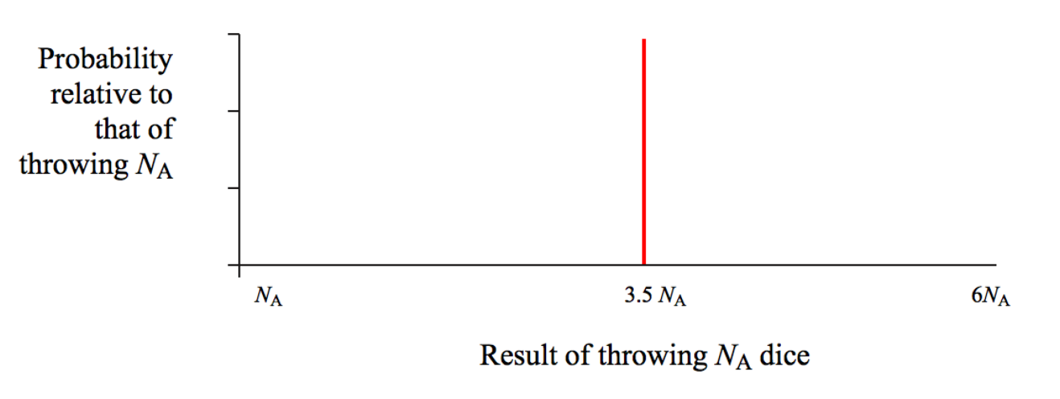

These graphs have shown the transition from probability to *determinism*. For two dice, one is governed very much by probability, although one can make some vague predictions, as is done in the game of craps. With Avogadro’s number of dice, we have determinism: we can predict with great certainty the outcome of throwing this many dice.

(c) The shaking of the table would randomize the dice so that the result would be that represented by the vertical line in the final graph in part (b). The middle of a probability curve for dice can be seen to be the average of the lowest and highest possible values, so the number obtained when all the numbers on the faces are added up is



(d) It is *extremely* unlikely that all the dice would end up with a 1 showing. It is *not* impossible, but there are so many other possibilities that the probability of all upward faces showing 1 is essentially zero.

(e) When studying thermodynamic systems, we don’t consider systems of one, two, or three particles. We consider systems with numbers of molecules similar to Avogadro’s number. Once the dice are thrown, the result is fixed and stays fixed, unlike a physical system, which changes from moment to moment. The shaking of the table represents time evolution in a physical system. The shaking of the table in part (c) represents a physical system evolving from a very low probability (low entropy) macrostate to a much higher probability (high entropy) macrostate. In part (d), once the high probability (high entropy) state has been achieved, it is extremely unlikely for the system to return to a low probability (low entropy) state. If the table is continuously shaken and then evaluated, the total number on the upward faces of the dice will always be very close to 3.5*N*A.

**Finalize** In part (c), can we actually do this experiment? Assuming we could gather Avogadro’s number of dice and that we had a table large enough and strong enough to support them, how long would it take to set up Avogadro’s number of dice with a 1 on the upper face?

Let’s assume we could turn two dice per second so that the face with a 1 is the upper face. The number of dice that have to be turned is (5/6)*N*A, since, by chance, 1/6 of the dice will already have their 1 face turned upward. The time interval required to turn the rest of the dice so their 1 face is turned upward is



This time interval is over half a million times the age of the Universe. That should suggest that the experiment cannot be carried out! A flat, square table to hold the dice would have to be almost 8 Gm on a side, larger than the diameter of the Earth. Estimating about 0.4 g per die, the mass of Avogadro’s number of dice is over 2 × 1019 kg, about the mass of a small asteroid.

*Answers:* (a)

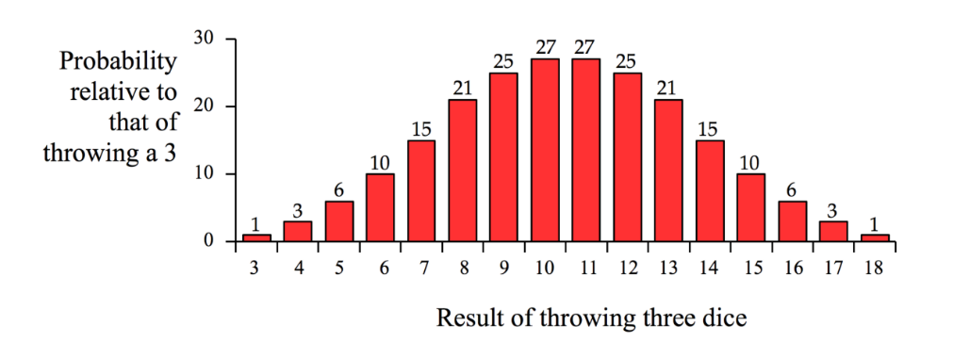

(b)

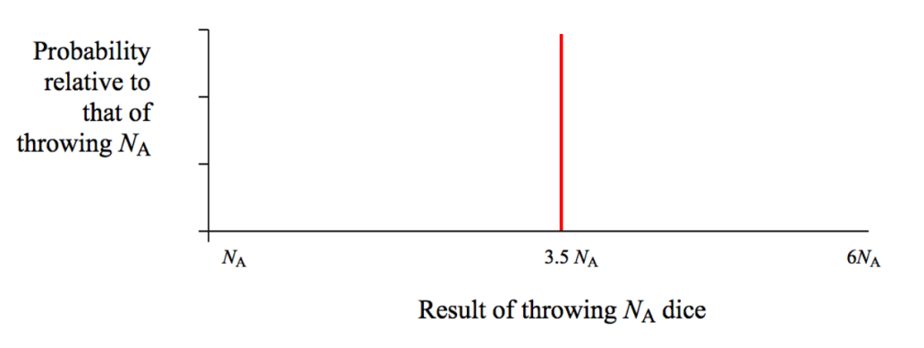

(c) 2.108 ×1024 (d) 0 (e) Answers will vary.

**\*TP21.3** The entropy change can be calculated using the result of Example 21.7, modified to reflect the phase change of boiling:



where *m* is the mass of the sample, *Lv*(kg) is the latent heat of vaporization in J/kg, *Lv*(mol) is the latent heat of vaporization in J/mol, *M* is the molar mass, and *Tb* is the boiling temperature. The expanded table below shows the results.

|  |  |  |  |  |
| --- | --- | --- | --- | --- |
|  | ***Lv* (kJ/mol)** | **Boiling Point (°C)** | **Boiling Point (K)** | **∆*S* per mole**  **(J/mol · K)** |
| *Polar compounds* |  |  |  |  |
| HF | 25.2 | 19.7 | 292.7 | 86.1 |
| HCl | 16.2 | –84.8 | 188.2 | 86.1 |
| HI | 19.8 | –35.6 | 237.4 | 83.4 |
| H20 | 40.7 | 100 | 373 | 109.1 |
| *Nonpolar compounds* |  |  |  |  |
| C3H8 | 19.0 | –42.1 | 230.9 | 82.3 |
| C4H10 | 22.4 | –0.50 | 272.5 | 82.2 |
| *Elements* |  |  |  |  |
| Hg | 54.7 | 357 | 630 | 86.8 |
| Pb | 178 | 1 749 | 2 022 | 88.0 |
| Cl2 | 20.4 | –34.0 | 239 | 85.4 |
| Br2 | 30.0 | 58.8 | 331.8 | 90.4 |

All but one of the entries in the rightmost column are in the range of 82 J/mol · K to 91 J/mol · K. This general pattern is called *Trouton’s rule.* It is related to the fact that entropy is related to the number of ways of locating particles. One mole of each of the substances above has the same number of particles. And those particles are all doing the same thing: changing from the liquid state to the vapor state. Therefore, it is not surprising that the entropy change has similar values for many of these substances.

There is an outlier. Water has a higher value, 109 J/mol · K. Water molecules exhibit hydrogen bonding, so they are not as free to move around in the liquid as in other liquid substances. There are fewer ways of locating the water molecules, so the initial entropy of the system is lower than expected. Therefore, the entropy change is larger when water vaporizes because the hydrogen bonds must be broken *and* the molecules must break into the vapor from the liquid surface.

Other substances also deviate from Trouton’s rule, with values both higher and lower than the typical range of values. The reasons for the deviation vary from one substance to another.

*Answers:* All but one of the entries have a value for ∆*S* between 82 and 91 J/mol · K

|  |
| --- |
| **SOLUTIONS TO END-OF-CHAPTER PROBLEMS** |

Section 21.1 Heat Engines and the Second Law of Thermodynamics

**P21.1** (a) We have 

With  we have 

(b) The work per cycle is



From the definition of output power,



we have the time for one cycle:



**P21.2** (a) The efficiency of a heat engine is , where *W*env is the work done by the engine and  is the energy absorbed from the higher temperature reservoir. Thus, if , the efficiency is .

(b) From conservation of energy, the energy exhausted to the lower temperature reservoir is  Therefore, if, we have or

**P21.3** The energy to melt a mass  of Hg is The energy absorbed to freeze  of aluminum is  The efficiency is



Section 21.2 Heat Pumps and Refrigerators

**P21.4** (a) The work done on the refrigerant in each cycle is



(b) The coefficient of performance of a refrigerator is:



Solving numerically:



P21.5 (a) The energy use by the freezer each day is



(b) From the definition of the coefficient of performance for a refrigerator,  the thermal energy removed from the cold space each day is



(c) The water must be cooled 20.0°C before it will start to freeze, so the thermal energy that must be removed from mass *m* of water to freeze it is The mass of water that can be frozen each day is then



**P21.6** (a) The coefficient of performance of a heat pump is



Because work (energy) is power times time  the equation above may be rearranged to obtain the heat added to the home:



(b) The coefficient of performance of a refrigerator or air conditioner is



and can be written in terms of the coefficient of performance of a heat pump because:





Where the first term on the far right is identically the coefficient of performance of the heat pump, and the second term is identically one (because ). Thus,



Section 21.4 The Carnot Engine

**P21.7** We use the Carnot expression for maximum possible efficiency, and the definition of efficiency to find the useful output. The engine is a steam turbine in an electric generating station with



(a) 

(b) 

for one second of operation, so



and the power is



**P21.8** The efficiency of a Carnot engine operating between these temperatures is



Therefore, there is no way that the inventor’s engine can have an efficiency of 0.110 = 11.0%.

**P21.9** We wish to evaluate  for a refrigerator, which is a Carnot engine run in reverse. For a Carnot engine,



which gives



Therefore,



**P21.10** (a) For a complete cycle,  and



The text shows that for a Carnot cycle (and only for a reversible cycle), . Therefore, .

(b) We have the definition of the coefficient of performance for a refrigerator, . Using the result from part (a), this becomes .

**P21.11** (a) The absolute temperature of the cold reservoir is   
*Tc* = 20.0° + 273 = 293 K. If the Carnot efficiency is to be   
*eC* = 0.650, it is necessary that



Thus,

 or 

(b) 

**P21.12** The Carnot summer efficiency is



And in winter,



Then the actual winter efficiency is



**\*P21.13** **Conceptualize In** Figure 21.2, imagine the hot reservoir to be the 20.0°C water at the surface of the ocean. The cold reservoir is the water at a lower depth at a temperature of 5.00°C.

**Categorize** The problem involves calculations using the model of a heat engine described in Section 21.1, along with some relatively simple energy calculations.

**Analyze** (a) Use Equation 21.8 to find the maximum possible efficiency, the Carnot efficiency, and substitute numerical values:



(b) Use Equation 21.2, solve for *Qh*, differentiate with respect to time, so that you can evaluate power, and substitute numerical values:



(c) To find the number of homes served by the system, divide the power output of the engine by the typical power use of a home:



(d) Applying Equation 16.38 to light, the intensity of sunlight on the surface is

 (1)

For the energy absorbed from sunlight to match the energy required for the engine, we must have

 (2)

Where *Ph* is the power input to the engine. Combining Equations (1) and (2), we have

 (3)

Substitute numerical values:



where the factor of 0.5 in the denominator represents the fact that the area on the ocean only has daylight for 12 hours a day. This area is a little under two square miles.

(e) The area of the Earth’s ocean surface can be looked up online and found to be about 3.6 × 1014 m2. Divide this area by the area *A* required for one engine to find the number of engines that could be operated:



Multiply this by the number of homes served by one engine:



The result is five trillion homes, which is much larger than the population of the Earth, a few billion. Therefore, this calculation shows that there is plenty of ocean surface area to operate the engines and supply the Earth’s electricity needs.

(f) These calculations assumed that the engines operated with Carnot efficiency. That will not be true in practice; the actual efficiency will be much lower. The calculation also includes only electricity use in homes; it does not include electricity use in industry and transportation. The temperature distribution in the ocean is in balance now, *with* the solar input on the surface and *without* the use of the engines. What will happen to the temperature distribution if we use some of the warmer water to run engines and transport that energy by electricity to the land surface? How would that affect ocean life? Another consideration is free passage in shipping lanes. If the ocean is crowded with mechanical systems associated with these engines, how does that affect passing ships? And then there are myriad political and economic questions regarding the use of these systems by various countries. If the system is used by only one country, can they operate it in the open ocean, or only within their 12-mile limit? What about landlocked countries that have no ocean surface available? If the system is used by several countries, which country is responsible for maintenance, repair, etc.? This will be a major concern with 180 million engines operating, as found in part (e). While the calculations we have performed may look promising, the introduction of such a system is fraught with difficulties and would need to be approached very carefully.

**Finalize** Notice the important difference discussed in part (f) between physics calculations and real-world considerations.

*Answers:* (a) 5.12% (b) 5.27 × 1012 J/h (c) 5.68 × 104 (d) 4.50 × 106m2 (e) yes (f) numerically, yes; feasibly, probably not

P21.14 (a) 

(b) We differentiate to find



(c) We differentiate *eC*=1 – *Tc*/*Th* to find



(d) 

**P21.15** (a) “The actual efficiency is two thirds the Carnot efficiency” reads as an equation



All the *T*’s represent absolute temperatures. Then







(b) 

(c) 

(d) We require



(e) The minimum possible heat exhaust power is approached as the firebox temperature goes to infinity, and it is 1.40 MW(0.5/1) = 0.700 MW. The heat exhaust power cannot be as small as (1/4)(1.87 MW) = 0.466 MW. So no answer exists. The energy exhaust cannot be that small.

**P21.16** (a) 

Now, *Q*2*h* = *Q*1*c* = *Q*1*h* − *W*eng1 = *Q*1*h* − *e*1*Q*1*h*,

so



(b) 

(c) 

(d) With 





(e) 



**P21.17** The coefficient of performance of the device is

COP = 0.100 COPCarnot cycle

or 



Thus, 1.17 joules of energy enter the room by heat for each joule of work done.

Section 21.5 Gasoline and Diesel Engines

**P21.18** Compression ratio = 6.00, *γ* = 1.40

(a) Efficiency of an Otto engine: 



(b) If actual efficiency *e’* = 15.0%, the fraction of fuel wasted is (assuming complete combustion of the air-fuel mixture) .

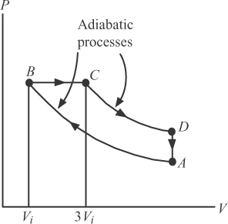**P21.19** The energy transferred by heat over the   
paths *CD* and *BA* is zero since they are   
adiabatic.

Over path *BC*: *QBC* = *nCP* (*TC* − *TB*) > 0

Over path *DA*: *QDA* = *nCV* (*TA* − *TD*) < 0

Therefore,  and *Qh* = *QBC*.

The efficiency is then

**ANS. FIG. P21.19**



Section 21.6 Entropy

**P21.20** (a) The table is shown in TABLE P21.20 below.

(b) On the basis of the table, the most probable recorded result of a toss is 

|  |  |  |
| --- | --- | --- |
| **Result** | **Possible Combinations** | **Total** |
| All heads | HHHH | 1 |
| 3H, 1T | THHH, HTHH, HHTH, HHHT | 4 |
| 2H, 2T | TTHH, THTH, THHT, HTTH, HTHT, HHTT | 6 |
| 1H, 3T | HTTT, THTT, TTHT, TTTH | 4 |
| All tails | TTTT | 1 |

**TABlE p21.20**

**P21.21** Each marble is returned to the bag before the next is drawn, so the probability of drawing a red one is the same as drawing a green one.

(a)

|  |  |  |
| --- | --- | --- |
| **Result** | **Possible Combinations** | **Total** |
| All red | RRR | 1 |
| 2R, 1G | RRG, RGR, GRR | 3 |
| 1R, 2G | RGG, GRG, GGR | 3 |
| All green | GGG | 1 |

**TABlE p21.21(a)**

(b)

|  |  |  |
| --- | --- | --- |
| **Result** | **Possible Combinations** | **Total** |
| All red | RRRRR | 1 |
| 4R, 1G | RRRRG, RRRGR, RRGRR, RGRRR, GRRRR | 5 |
| 3R, 2G | RRRGG, RRGRG, RGRRG, GRRRG, RRGGR, RGRGR, GRRGR, RGGRR, GRGRR, GGRRR | 10 |
| 2R, 3G | GGGRR, GGRGR, GRGGR, RGGGR, GGRRG, GRGRG, RGGRG, GRRGG, RGRGG, RRGGG | 10 |
| 1R, 4G | RGGGG, GRGGG, GGRGG, GGGRG, GGGGR | 5 |
| All green | GGGGG | 1 |

**TABlE p21.21(b)**

Section 21.7 Entropy in Thermodynamic Systems

**P21.22** The hot water has negative energy input by heat, given by  The surrounding room has positive energy input of this same number of joules, which we can write as  Imagine the room absorbing this energy reversibly by heat, from a stove at 20.001°C. Then its entropy increase is *Q*room/*T*:



**P21.23** The car ends up in the same thermodynamic state as it started, so it undergoes zero changes in entropy. The original kinetic energy of the car is transferred by heat to the surrounding air, adding to the internal energy of the air. Its change in entropy is



**P21.24** Each gas expands into the other half of the container as though the other gas were not there; therefore, consider each gas to undergo a free expansion process in which its volume doubles. From Equation 21.17, the entropy change is twice that for a single gas:



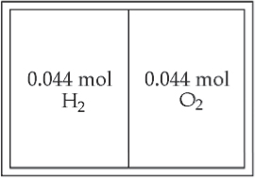

**ANS. FIG. P21.24**

**P21.25** The change in entropy is given by



Here *T* means the absolute temperature. We would ordinarily think of *dT* as the change in the Celsius temperature, but one Celsius degree of temperature change is the same size as one kelvin of change, so *dT* is also the change in absolute *T*.



**P21.26** We take data from Tables 19.1 and 19.2, and we assume a constant specific heat for each phase. As the ice is warmed from –12.0°C to 0°C, its entropy increases by



As the ice melts its entropy change is



As liquid water warms from 273 K to 373 K,



As the water boils and the steam warms,





The total entropy change is



For steam at constant pressure, the molar specific heat in Table 19.1 implies a specific heat of  nearly agreeing with 2 010 J/kg . K.

Section 21.8 Entropy and the Second Law

**P21.27** The change in entropy of a reservoir is  where *Qr* is the energy absorbed (*Qr*> 0) or expelled (*Qr*< 0) by the reservoir, and *T* is the absolute temperature of the reservoir.

(a) For the hot reservoir: 

(b) For the cold reservoir: 

(c) For the Universe:



**P21.28** The change in entropy of a reservoir is  where *Qr* is the energy absorbed (*Qr*> 0) or expelled (*Qr*< 0) by the reservoir, and *T* is the absolute temperature of the reservoir.

(a) Energy is transferred from the hot reservoir by heat: and .

(b) Energy is transferred to the cold reservoir by heat: and .

(c) For the Universe, .

**P21.29** Sitting here writing, I convert chemical energy from molecules in food, into internal energy that leaves my body by heat into the room-temperature surroundings. My rate of energy output is equal to my metabolic rate,



My body is in steady state, changing little in entropy, as the environment increases in entropy at the rate



When using powerful appliances or an automobile, my personal contribution to entropy production is much greater than the above estimate, based only on metabolism.

**P21.30** The conversion of gravitational potential energy into kinetic energy as the water falls is reversible. But the subsequent conversion into internal energy is not. We imagine arriving at the same final state by adding energy by heat, in amount *mgy*, to the water from a stove at a temperature infinitesimally above 20.0°C. Then,



**Additional Problems**

**P21.31**  and for an engine, 

(a) 

(b) 

**P21.32** (a) 

(b) The energy extracted by heat from the cold side divided by required work input is by definition the coefficient of performance for a refrigerator: 

(c) With an EER of 5,



which gives



Energy purchased is 

:



With EER 10,



Energy purchased is 

:





**P21.33** (a) For the constant volume process AB,



(b) For an isothermal process, .

Therefore, for process *BC*, .

(c) For the constant volume process *CD*,



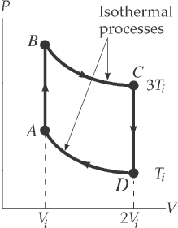

**ANS. FIG. P21.33**

(d) For an isothermal process *DA*, 

(e) 

(f) Since the change in temperature for the complete cycle is zero,

and

and work done by the engine is



(g) The efficiency is



**P21.34** (a) The coefficient of performance of an air conditioner is defined as



But when a device operates on the Carnot cycle, Thus, the coefficient of performance for a Carnot heat pump would be



(b) From the result of part (a) above, we observe that the COP of a Carnot air conditioner would increase if the temperature difference *Th*– *Tc*becomes .

(c) If  the COP of a Carnot heat pump would be



**P21.35** (a) Let state *i* represent the gas before its compression and state *f* afterwards, . For a diatomic ideal gas,  and  Next,



so 



Since the process is adiabatic, *Q* = 0 and  gives



(b) The moment of inertia of the wheel is



We want the flywheel to do work 39.4 J, so the work on the flywheel should be –39.4 J:



(c) Now we want 



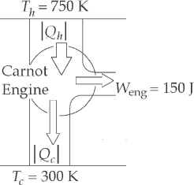**P21.36** For the Carnot engine,

**ANS. FIG. P21.36**



Also, 

so

and

(a) 



(b) When engine S delivers 150 J of work to the Carnot engine, the Carnot engine transfers 250 J to the firebox while engine S takes 214 J from the firebox:



and the Carnot engine removes 100 J from the environment while engineS returns 64.3 J:





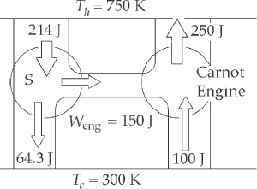

**ANS. FIG. P21.36(a–b)**

(c) 

(d) For engine S: 

so work output is 

and energy input to engine S is



(e) Engine S contributes 150 J out of 233 J to running the Carnot engine:



This is the net energy lost by the firebox.

(f) The remaining work output is



(g) 

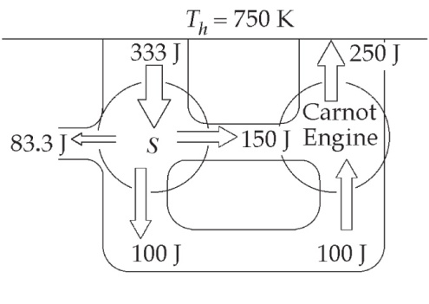

**ANS. FIG. P21.36(e–g)**

(h) 

(i) Both engines operate in cycles, so 

For the reservoirs,  and 

Thus,



(j) 

Challenge Problem

**P21.37** (a) For the isothermal process *AB*, the work on the gas is



where we have used 1.00 atm = 1.013 × 105 Pa and   
1.00 L = 1.00 × 10–3 m3.



and

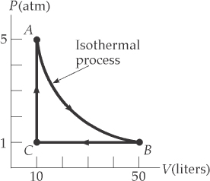

**ANS. FIG. P21.37**

(b) Since *AB* is an isothermal process, 

and*QAB* = –*WAB* = 8.15 × 103 J.

For an ideal monatomic gas, and 



Also, 



so the total energy absorbed by heat is



(c) 



(d)  or 

(e) A Carnot engine operating between *T*hot = *TA* = 5 060/*R* and *T*cold = *TC* = 1 010/*R* has  80.0%. The efficiency of the cycle is much lower than that of a Carnot engine operating between the same temperature extremes.

**P21.38** (a) The ideal gas at constant temperature keeps constant internal energy. As it puts out energy by work in expanding, it must take in an equal amount of energy by heat. Thus its entropy increases. Let *Pi* ,*Vi* , and *Ti* represent the state of the gas before the isothermal expansion. Let *PC* ,*VC* , and *Ti* represent the state after this process, so that *PiVi* = *PCVC*. Let *Pi* , 3*Vi* , and *Tf* represent the state after the adiabatic compression.

Then 

Substituting 

gives 

Then  and 

The work output in the isothermal expansion is



This is also the input heat, so the entropy change is



Since 

we have 

and

Then the result is

(b) 

**P21.39** We recognize that *T*c = *T*1 and *T*h = *T*2, and *Q*c = 350 J and *Q*h = –1 000 J.



(a) 

(b) 



(c) 

**\*P21.40 Conceptualize** You may not be familiar with a *TS* diagram, but if you compare the phrase to “*PV* diagram,” it must be the same type of graph, but with temperature *T* on the vertical axis and entropy *S* on the horizontal axis.

**Categorize** The problem statement tells us to restrict our attention to two types of cycles, the Carnot cycle and the Otto cycle.

**Analyze** (a) Let’s begin with the Carnot cycle, whose *PV* diagram is shown in Figure 21.10. We begin at point *A* in the figure and follow the four processes in the cycle. The process *A*→*B* is isothermal. On a *TS* diagram, this process must be represented by a horizontal line, since the temperature remains fixed. Because energy enters the gas during this process, the entropy of the gas increases, so the horizontal line must be directed to the right. For the reversible adiabatic process *B*→*C*, the entropy of the gas does not change, so the process must be represented by a vertical line at a fixed entropy on the *TS* diagram. The line is directed downward because the temperature drops from *Th* to *Tc*. For the isothermal process *C*→*D*, we have a horizontal line directed to the left as energy leaves the gas by heat and the entropy drops. Finally, process *D*→*A* is represented by a horizontal line directed upward and closing the path. Therefore, the *TS* diagram you should prepare for the presentation slide looks like this:

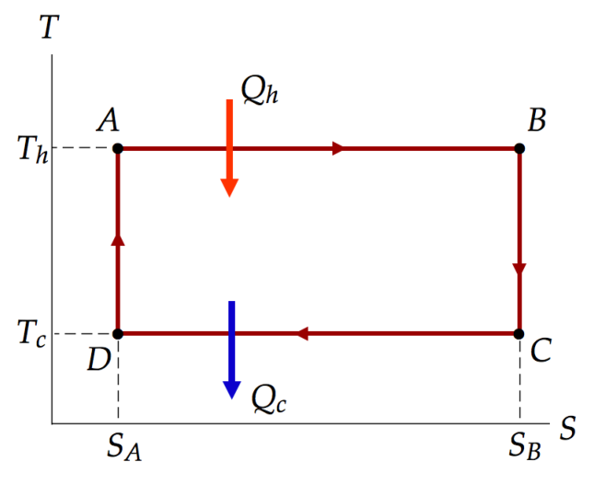

You might also want to add the following information to the slide. From Equation 21.12,

 (1)

Therefore, the area under the curve on a *TS* diagram is the heat if the process is reversible. In the diagram above for the reversible Carnot engine, heat *Qh* is the rectangular area underneath the upper horizontal line and heat *Qc* is the rectangular area underneath the lower horizontal line. The difference between the two heats is the area surrounded by the rectangular path and, according to Equation 21.1, is the work done by the engine. Therefore, the work done by the engine is the area enclosed by the path on both a *PV* diagram and a *TS* diagram!

(b) Let’s now consider the Otto cycle, shown in the *PV* diagram in Figure 21.12. The processes *O*→*A* and *A*→*O* are difficult to represent on a *TS* diagram. (See the Finalize step for more information.) So we will focus on just the cycle *A*→*B* →*C* →*D*.

We begin at point *A* in the figure and follow the four processes in the cycle. The process *A*→*B* is adiabatic. On a *TS* diagram, this process must be represented by a vertical line, since the entropy of the gas remains fixed. Because the temperature of the gas increases during this process, the vertical line must be directed upward. For the isovolumetric process *B*→*C*, in which the spark plug fires, the temperature and entropy of the gas both increase, so the process is represented by a curved line directed toward the upper right on the *TS* diagram. For the adiabatic process *C*→*D*, we have a vertical line directed downward as the temperature drops but the entropy remains fixed. Finally, process *D*→*A* is another isovolumetric process that occurs as the exhaust valve is opened, closing the path. Therefore, the *TS* diagram you should prepare for the presentation slide looks like this:

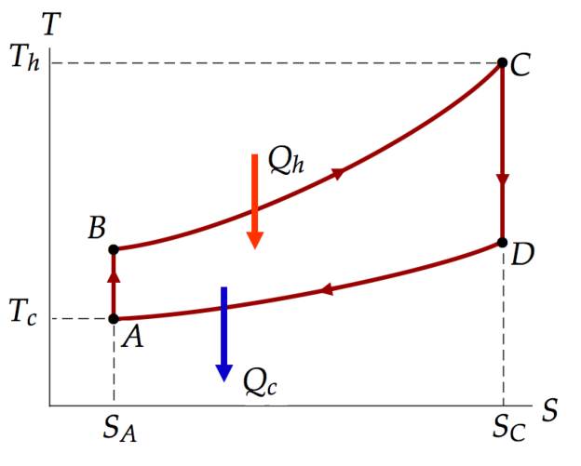

**Finalize** Consider the statement made above that the processes *O*→*A* and *A*→*O* are difficult to represent on a *TS* diagram. Actually, they are difficult on a *PV* diagram, too. Figure 21.12 shows the pressure remaining constant and the volume changing as the fuel mixture is drawn into the cylinder in *O*→*A* and then expelled in *A*→*O*. But it appears that the temperature increases in *O* →*A*, since *O* is on a lower isotherm. This is not accurate; the temperature of the fuel mixture does not change as it is brought into the cylinder. The internal energy in the cylinder does indeed increase, because more gas is brought into the cylinder, but the change is in *n*, the number of moles of gas in the cylinder, not the temperature *T*. This confusion is due to the fact that an automobile engine does not quite match the definition of a heat engine because it doesn’t take the *same* sample of gas and run it through multiple cycles. It brings in a sample of gas, runs it through *one* cycle, and then expels it. The next cycle is run on a *new* sample of gas. In a true heat engine, there is no intake and exhaust of the gas during the cycle; the same gas always remains within the engine.

*Answers:*

(a) 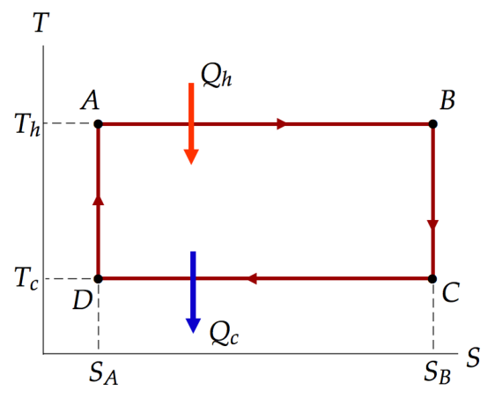 (b) 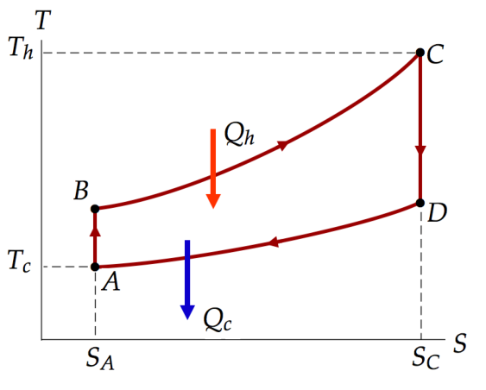

**\*P21.41** **Conceptualize** In Figure 21.2, the warm reservoir is the steam. The cold reservoir is the water being rejected into the stream. The work output is represented by the 1.00 GW of electrical power.

**Categorize** In part (a) we are told to categorize the heat engine in the power plant as operating in a Carnot cycle.

**Analyze** From Equation 19.4, we can relate energy going into the stream to the flow rate of the stream and the temperature increase of the water in the stream:



where*c* is the specific heat of water. Solve for the temperature change of the water:

 (1)

where we have recognized the energy going into the stream as that rejected from the power plant. Now, from Equation 21.1,

 (2)

Use Equation 21.2 to substitute for *Qh*:

 (3)

Imagine energy exchanges that take place over a time interval ∆*t*, so we can express Equation (3) with the power:

 (4)

Because the power plant is operating at Carnot efficiency, use Equation 21.8 for the efficiency:

 (5)

Substitute Equation (5) into Equation (1):

 (6)

Substitute numerical values:



(b) Let’s respond to this question algebraically. We can follow the analysis in part (a) through Equation (4), but cannot substitute the Carnot efficiency as we did in Equation (5).

Substitute Equation (4) into Equation (1):

 (7)

The efficiency *e* in this equation is smaller than that for a Carnot engine. Imagine reducing *e* in Equation (7) to a smaller value. This will *increase* the change in the water temperature,making it higher than that found in part (a).

(c) Substitute numerical values into Equation (7):



**Finalize** The conclusion in part (b) makes sense conceptually. If the engine is operating at a lower efficiency, less energy is leaving as the useful electrical output of the engine, and more is being rejected to the stream, raising the water temperature further. The change in water temperature in part (c) is much higher than that claimed by the utility, and could be damaging to the fish in the stream.

*Answers:* (a) 5.97 K (b) higher (c) 22.6 K

**\*P21.42** **Conceptualize** In Figure 21.2, the warm reservoir is the steam. The cold reservoir is the water being rejected into the stream. The work output is represented by *P*.

**Categorize** In part (a) we are told to categorize the heat engine in the power plant as operating in a Carnot cycle.

**Analyze**  From Equation 19.4, we can relate energy going into the stream to the flow rate of the stream and the temperature increase of the water in the stream:



where*c* is the specific heat of water. Solve for the temperature change of the water:

 (1)

where we have recognized the energy going into the stream as that rejected from the power plant. Now, from Equation 21.1,

 (2)

Use Equation 21.2 to substitute for *Qh*:

 (3)

Imagine energy exchanges that take place over a time interval ∆*t*, so we can express Equation (3) with the power:

 (4)

Because the power plant is operating at Carnot efficiency, use Equation 21.8 for the efficiency:

 (5)

Substitute Equation (5) into Equation (1):

 (6)

(b) We can follow the analysis in part (a) through Equation (4), but cannot substitute the Carnot efficiency as we did in Equation (5). Substitute Equation (4) into Equation (1):

 (7)

(c) The efficiency *e* in this equation is smaller than that for a Carnot engine. This will *increase* the change in the water temperature,making it higher than that found in part (a).

**Finalize** The conclusion in part (c) makes sense conceptually. If the engine is operating at a lower efficiency, less energy is leaving as the useful electrical output of the engine, and more is being rejected to the stream, raising the water temperature further. The change in water temperature in part (b) is much higher than that claimed by the utility, and could be damaging to the fish in the stream.

*Answers:* (a)  (b)    
(c) higher

**P21.43** (a) water: 

body: 



(b) Conservation of energy,  gives



Solving for *TF*,



(c) 

(d) 

**P21.44** When energy enters a substance by heat, we describe the process with Equation 20.4, This is a reversible process; if energy leaves the substance, the temperature drops down again. Therefore, the entropy change for one of the samples of water is



Consequently, the entropy change for both samples of water is







**P21.45** (a) 

(b) 

(c) 

**P21.46** 



Challenge Problem

**P21.47** The quantity of gas is



(a) In process *A*→‏*B*,







State C:

*VC* = *VB*



State D:

*VD* = *VA*

In process *C*→*D*:



TABLE P21.47 (a) tabulates these results:

|  |  |  |  |
| --- | --- | --- | --- |
|  | *T* (*K*) | *P* (kPa) | *V* (cm3) |
| *A* | 293 | 100 | 500 |
| *B* | 673 | 1.84 × 103 | 62.5 |
| *C* | 1023 | 2.79 × 103 | 62.5 |
| *D* | 445 | 152 | 500 |

**TABLE P21.47 (a)**

(b) In the adiabatic process *A*→*B*, *Q* = 0,



and 

In the isovolumetric process *B*→*C*, *W* = 0



In the adiabatic process *C*→*D*, *Q* = 0



For the entire cycle, 



TABLE P21.47 (b) tabulates these results:

|  |  |  |  |
| --- | --- | --- | --- |
|  | *Q* | *W*eng |  |
| *A*→*B* | 0 | –162 | 162 |
| *B*→*C* | 149 | 0 | 149 |
| *C*→*D* | 0 | 246 | –246 |
| *D*→*A* | –65.0 | 0 | –65.0 |
| *ABCD* | 84.3 | 84.3 | 0 |

**TABLE P21.47 (b)**

(c) From B→C, the input energy is.

(d) From D→A, the energy exhaust is .

(e) From ABCDA,.

(f) The efficiency is: 

(g) Let *f* represent the angular speed of the crankshaft. Then  is the frequency at which we obtain work in the amount of 84.3 J/cycle:



|  |
| --- |
| **ANSWERS TO QUICK-QUIZZES** |

**1.** (i) (c) (ii) (b)

**2.** (d)

**3.** C, B, A

**4.** (a) one (b) six

**5.** (a)

**6.** false (The adiabatic process must be *reversible* for the entropy change to be equal to zero.

|  |
| --- |
| **ANSWERS TO EVEN-NUMBERED PROBLEMS** |

**P21.2** (a) 0.25 or 25%; (b) 

**P21.4** (a) 75.0 kJ (b) 7.33

**P21.6** (a) 2.65 × 107 J; (b) 3.20

**P21.8** The efficiency of a Carnot engine operating between these temperatures is 6.83%. Therefore, there is no way that the inventor’s engine can have an efficiency of 0.110 = 11.0%.

**P21.10** (a) See P21.10 (a) for the full solution; (b) See P21.10 (b) for the full solution.

**P21.12** 0.330 or 33.0%

**P21.14** (a) 0.300; (b) 1.40 × 10−3 K−1; (c) −2.00 ×10−3 K−1; (d) No. The derivative in part (c) depends only on Th

**P21.16** (a) See P21.16 (a) for full explanation; (b) ; (c) The combination of reversible engines is itself a reversible engine so it has the Carnot efficiency. No improvement in net efficiency has resulted; (d);   
(e) 

**P21.18** (a) 51.2%; (b) 36.2%

**P21.20** (a) See TABLE P21.20; (b) 2 heads and 2 tails

**P21.22** 143 J/K

**P21.24** 0.507 J/K

**P21.26** 244 J/K

**P21.28** (a); (b); (c) 

**P21.30** 8.36 × 106 J/K · s

**P21.32** (a) 2.93; (b) (COP)refrigerator; (c) with EER 5, $510, with EER 10, $255; Thus, the cost for air conditioning is half as much for an air conditioner with EER 10 compared with an air conditioner with EER 5.

**P21.34** (a) ; (b) smaller; (c) 14.6

**P21.36** (a) 214 J and 64.3 J; (b) 35.7 J and 35.7 J. The total energy the firebox puts out equals to the total energy transferred to the environment; (c) The net flow of energy by heat from the cold to the hot reservoir without work input is possible; (d)  = 233 J, = 333 J; (e) 83.3 J; (f) 83.3 J; (g) 0; (h) The output of 83.8 J of energy from the heat engine by work in a cyclic process without any exhaust by heat is impossible; (i) −0.111 J/K; (j) A decrease in total entropy is impossible.

**P21.38** (a)  (b) The pair of processes considered here carries the gas from the initial state in P21.46 to the final state here. Entropy is a function of state. Entropy change does not depend on path. Therefore, the entropy change in P21.46 equals  in this problem. Since the answers to P21.46 and P21.38 (a) must be the same.

**P21.40** (a)  (b) 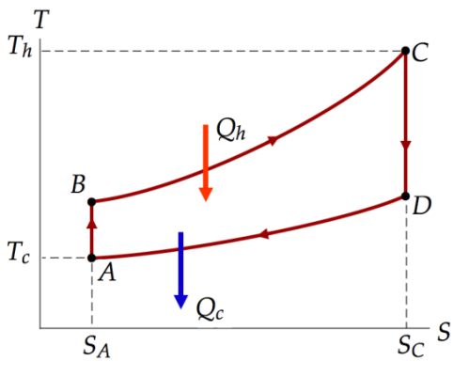

**P21.42**  (a) (b)  (c) higher

**P21.44** The computed change in entropy is 4.88 J/K, which is not zero. While the statements about energy transfer by heat are true, the mixing process is irreversible. After the water has come to equilibrium, it will not spontaneously separate again into warm and cool water. Therefore, there is an entropy increase of the mixture during the irreversible process.

**P21.46** nCPln 3